* **NAME: ROSHNI RAZA**
* **SAP ID: 61278**
* **COURSE: COAL**
* **LAB: 8**

***TASK: 1***

.model small

.stack 100h

.data

.code

main proc

mov dl,'1'

mov cx,5

mov ah,2

label1:

int 21h

add dl,2

loop label1

mov dx,10

mov ah,2

int 21h

mov dx,13

int 21h

mov ah,4ch

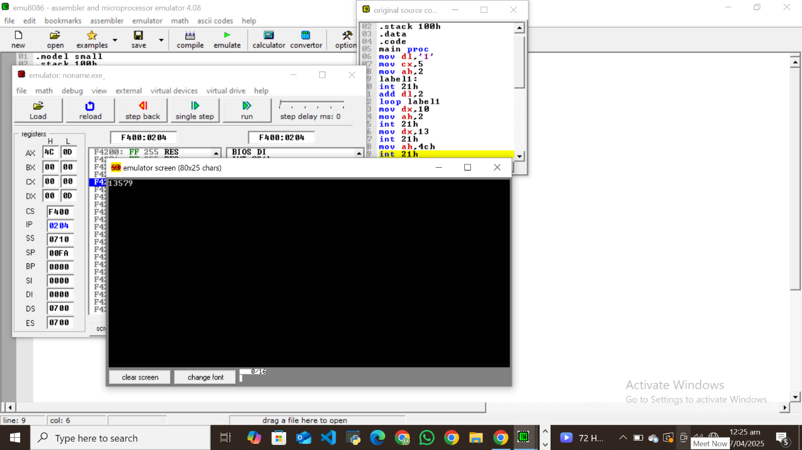int 21h

main endp

end main

***TASK: 2***

org 100h

.stack 100h

.model small

.data

.code

main proc

mov cx,5

mov dx,56

PrintevenNumbers:

mov ah,2

int 21h

sub dx,2

Loop PrintEVENNumbers:

mov ah,4ch

int 21h

main endp

end main

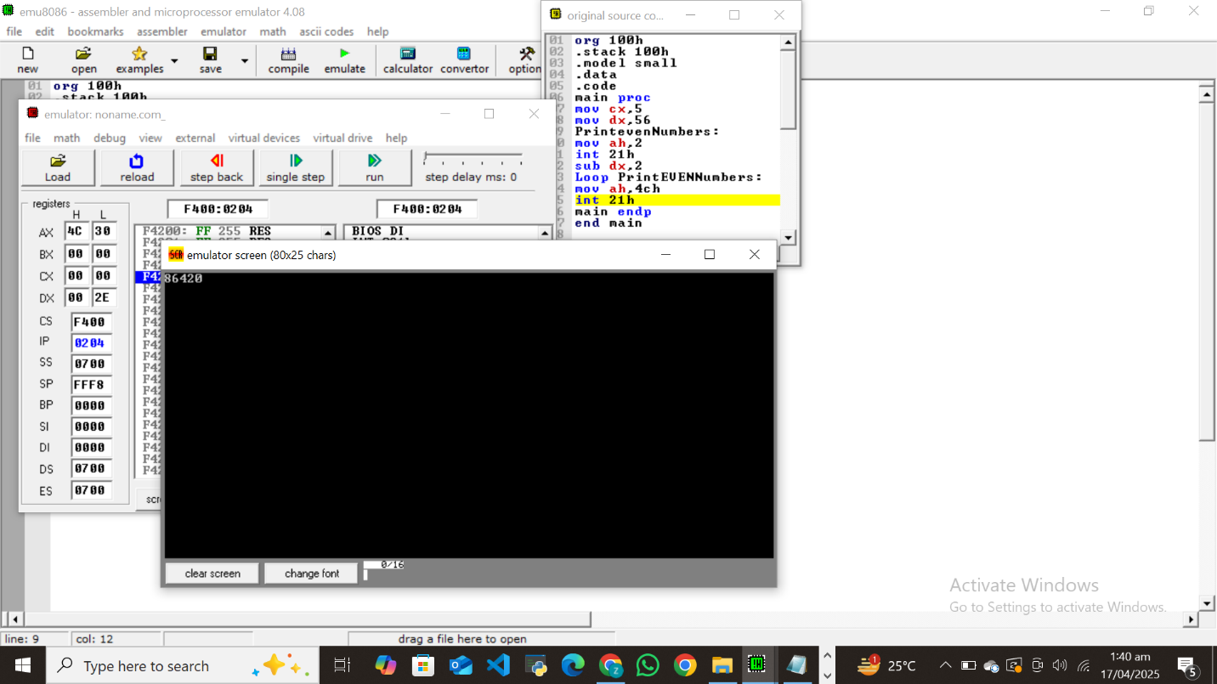

***TASK: 3***

.model small

.stack 100h

.data

sum db 0

.code

main proc

mov ax, @data

mov ds, ax

mov al, 2

add al, 4

add al, 3

add al,'0'

mov ah,2

mov dl,al

int 21h

mov ah, 4Ch

int 21h

main endp

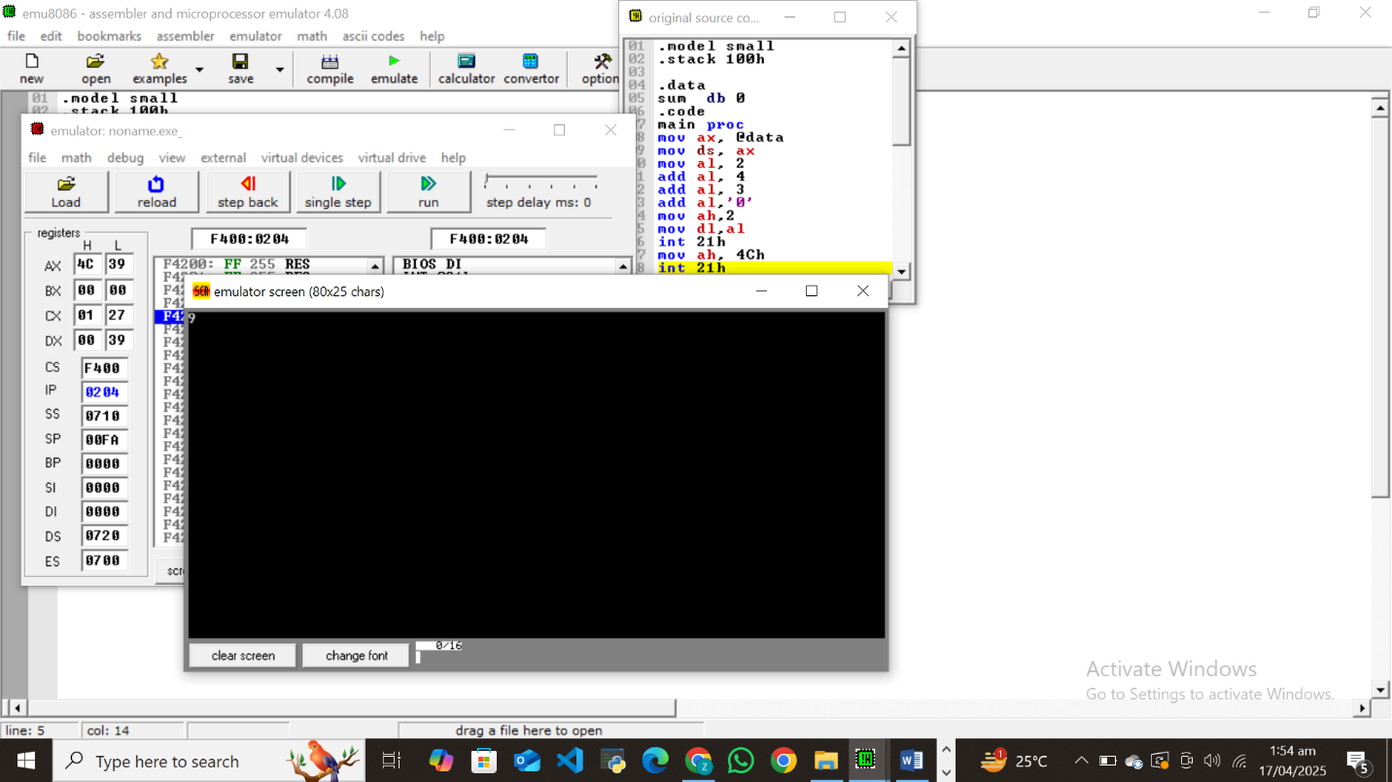end main

***TASK: 4***

.model small

.stack 100h

.data

letter db 'a'

.code

main proc

mov ax, @data

mov ds, ax

mov dl, 'a'

next_letter:

mov ah, 02h

int 21h

inc dl

cmp dl, 'z'+1

jne next_letter

mov ah, 4Ch

int 21h

main endp

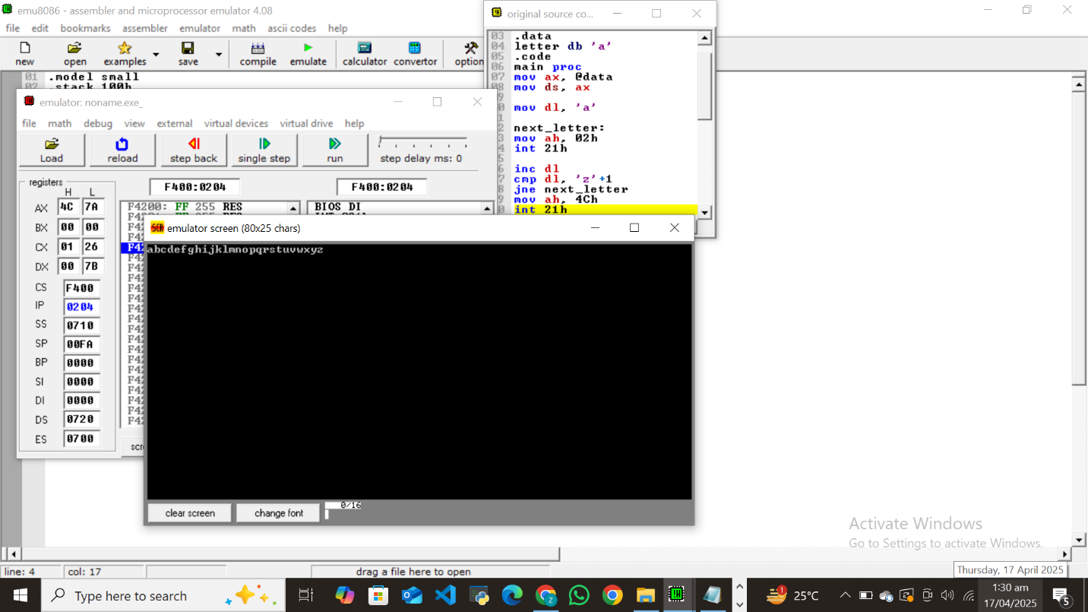end main

***TASK: 5***

.model small

.stack 100h

.data

newline db 13, 10, '$'

.code

main proc

mov ax, @data

mov ds, ax

mov cx, 11

mov bl, 10

print_loop:

mov al, bl

cmp al, 10

jl one_digit

mov dl, '1'

mov ah, 02h

int 21h

mov dl, '0'

int 21h

jmp print_newline

one_digit:

add al, '0'

mov dl, al

mov ah, 02h

int 21h

print_newline:

lea dx, newline

mov ah, 09h

int 21h

dec bl

loop print_loop

mov ah, 4Ch

int 21h

main endp

end main

